CS766 Project Proposal
Team Members:
- Jake Clifford (ID: 9084989467)
- Tyler Caspar (ID: 9079281912)
1) Problem Statement Fused Deposition Modeling (FDM) 3D printing is highly susceptible to mechanical failures, with a vast majority of critical errors originating from poor first-layer adhesion. If the printer's Z-offset is too high, the extruded filament lines fail to fuse, leaving structural gaps . If the nozzle is too low, the plastic over-extrudes into overlapping ridges . We aim to build a classical computer vision pipeline that dynamically analyzes a top-down image of a completed first layer to mathematically classify its structural quality based on the geometric density of the extruded lines.
Bad vs Good base layer
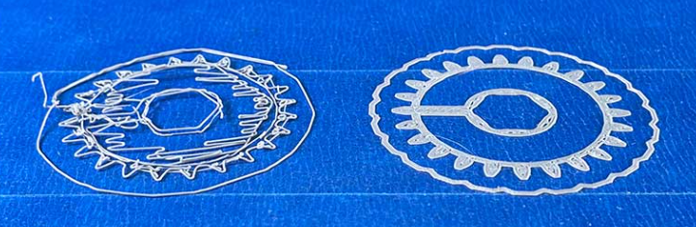
Source: https://www.simplify3d.com/5-simple-steps-to-a-perfect-first-layer/
2) Motivation First-layer errors often do not cause catastrophic print failures until hours into a print job, resulting in significant wasted time and material. We are interested in this problem because it replaces a highly subjective, manual human evaluation process—physically running a finger over the print or guessing the exact millimeter Z-offset—with a deterministic, measurable software solution.
3) Current State-of-the-Art Current software solutions for 3D printing defect detection rely almost exclusively on deep Convolutional Neural Networks (such as YOLO or EfficientNet) monitoring live video feeds. These models act as "black boxes" trained to detect catastrophic, late-stage failures like severe warping or tangled "spaghetti" filament. While effective for monitoring, they are reactive rather than proactive.
4) Proposed Approach We propose a novel classical computer vision pipeline that evaluates the geometric texture of the first layer without requiring the source G-code. Sourcing our dataset from publicly available 3D printing timelapse videos (e.g., Kaggle datasets or YouTube), we will extract frames of completed first layers.
To dynamically identify the printed shape, we will build a custom background subtraction and connected-component (flood-fill) algorithm to generate a Region of Interest (ROI) mask. Within this mask, we will implement our own Canny Edge Detection pipeline —writing the Gaussian blur convolutions, Sobel gradient operators, and hysteresis thresholding from scratch.
The algorithm will calculate the 'fill density' by comparing the ratio of detected internal edge pixels to the total solid area of the dynamically generated mask. To accurately classify the exact type of adhesion error (Optimal, Under-extruded, or Over-extruded), we will augment this edge density metric by analyzing either the gradient direction and magnitude from our Sobel operators, or the spatial frequencies of the extrusion lines using Fourier-domain analysis.
5) Justification Deep learning approaches are computationally heavy, require massive annotated datasets, and only detect failures after a print is already ruined. Our geometric approach is highly transparent, mathematically interpretable, and catches micro-errors at layer one to actively prevent macro-errors later. We believe our solution will work better for early detection because evaluating line gaps via edge gradients is a direct measurement of physical adhesion quality.
6) Evaluation and Timeline We will evaluate our pipeline against a manually curated dataset of 50-75 top-down first-layer frames extracted from online repositories. Performance will be measured using a confusion matrix to calculate Precision, Recall, and the F1-score across three target categories: Optimal Fusion, Under-extruded (Gaps), and Over-extruded (Ridges).
- Feb 26 – Mar 10: Scrape video datasets, extract target frames, implement image alignment/homography, and write the custom NumPy convolution matrix functions.
- Mar 11 – Mar 25: Implement the background subtraction, dynamic masking, and custom Canny Edge pipeline. Submit Mid-Term Report.
- Mar 26 – Apr 15: Refine the fill-density ratio math, implement gradient/frequency analysis for error classification, and evaluate the full pipeline against the extracted test frames.
- Apr 16 – Apr 29: Finalize evaluation metrics and prepare the in-class final presentation.
- Apr 30 – May 6: Polish the project webpage and upload the final source code.

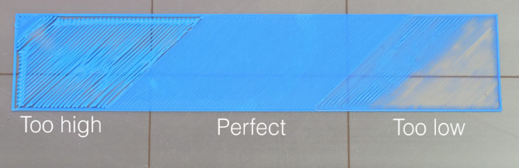
Source: https://3dprintingperth.com

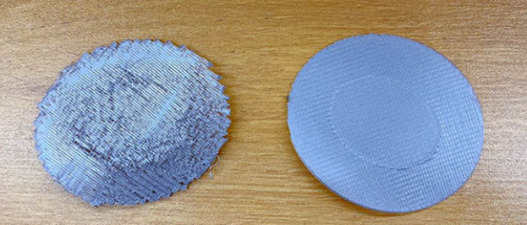
Source: https://store.anycubic.com/

